
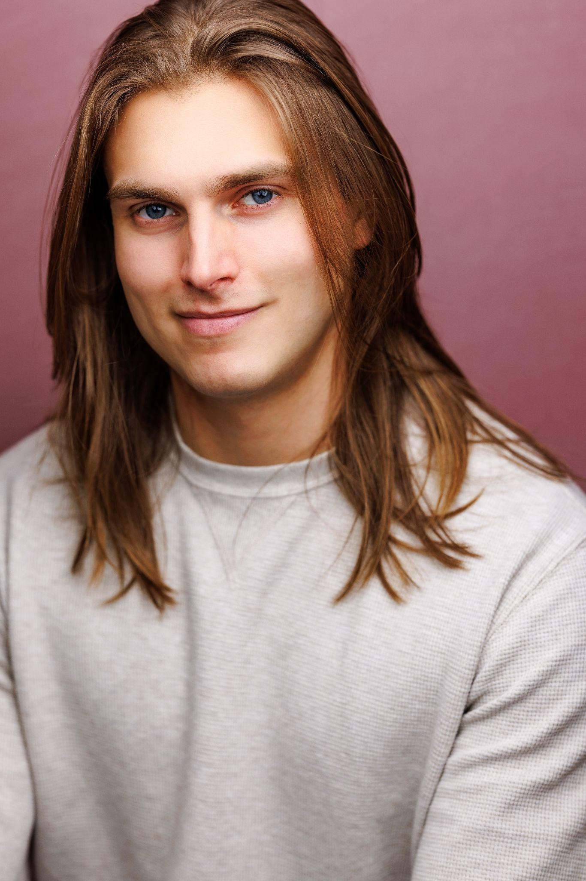
Donny Nikola
donnynikola@gmail.com

⎹ Height: 6’0⎹ Baritenor G2 - A5⎹ He/Him⎹

THEATRE

Jesus Christ Superstar | Simon (U/S Jesus) | Palace Theatre
The Lightning Thief | Percy Jackson | Pegasus Production Company
The Wedding Singer | Robbie Hart | Spring Lake Theatre
Grease | Danny Zuko | Jack Nicholson Theatre
Tommy | Lover (U/S Tommy) | Algonquin Arts Theatre
Blind Injustice | Featured Chorus | Jazz at Lincoln Center
CRUISE LINES
Up With A Twist (Cast 1) | Phil Collins | Brilliant Lady, Virgin Voyages
Duets (Cast 1) | Male Vocalist | Brilliant Lady, Virgin Voyages
EDUCATIONAL THEATRE AND TRAINING
Jesus Christ Superstar | Jesus | Montclair State University
Spring Awakening | Adult Men | Montclair State University
Bright Star | Station Master | Montclair State University

Acting:
Mark Hardy, David J.V Meenan, Nurit Montecelli, Maddie Corman, and Tyrone Henderson.

Voice:
Peter Van Derick and Dawne Mechlinski.

Dance:
Ryan Kasprzak (Tap), David J.V. Meenan (Tap), Lisa Harvey (Jazz), Geoggrey Doig-Marx (Jazz),

Stage Combat:
Rick Sordelet and Collin Sordelet.

SPECIAL SKILLS
Guitar (advanced), Piano (intermediate), Banjo (intermediate), Handwhistle birdcalls, Side splits,
One finger snap, One hand clap, Riding down stairway handles, Valid US Drivers License & Passport.

